An experiment with a thermoelectric module to validate the thermoelectric model of TCCbuilder

Laboratory for refrigeration and district energy, Faculty of Mechanical Engineering, Ljubljana

A simple experiment is designed to validate the thermoelectric (TE) model of TCCbuilder. A TE module is placed between a heat source and a heat sink as shown in Figure 1.

Figure Scheme of the experiment with TE module.

The heat source is a stainless steel plate with dimensions of 10 x 10 x 5 mm (length, width, thickness). The TE module is from Custom Thermoelectric, US. The dimensions of the module are 10 x 10 x 1.6 mm. The maximum current is 3.2 A, the maximum voltage is 6 V, the maximum cooling capacity is 11.4 W and the maximum temperature difference is 70 K. The heat sink is a 8 mm thick copper plate with attached fins for better convection. Lateral dimensions of the copper plate are 30 x 30 mm.

A 1D heat transfer from the heat source to the heat sink was investigated. Temperatures *T1*, *T2*, and *T3* were measured in the steady state using type T thermocouples. The measurement error is estimated at 1 K.

The measurements were carried out at electrical currents (DC) of *I* = 0.3 A, *I* = 0.5 A, and *I* = 0.75 A through the TE module, with the direction of the DC selected so that the TE module pumped the heat from the heat source to the heat sink.

The temperatures from the experiment were compared with those from the simulation. In the simulation, some parameters had to be adjusted to take all cases into account, as we do not know the exact values. These parameters are the electrical resistance of the modules, which was set to *ζ* = 2 µΩm, the Seebeck coefficient, which was set to *S* = -170 µVK-1, the convection coefficient at the top, which, was set to *ht*= 800 Wm-2K-1, and the convection coefficient at the bottom, which was set to *hb*= 1200 Wm-2K-1. The order of magnitude for the convection coefficient was calculated from natural convection and taking into account the effective heat transfer area, rather than the surface area of a TE pellet as considered in the model.

The graphs in Figures 2-4 show the comparison of the measured and TCCbuilder calculated temperatures for all three values of electric current. Position 0 mm is at the top of the heat source (*T1*), and progresses towards the heat sink. Considering that the manufacturer does not provide any information on the material properties used in the TE modules, we conclude that the results are sufficient to validate the model, provided that further investigations are carried out.

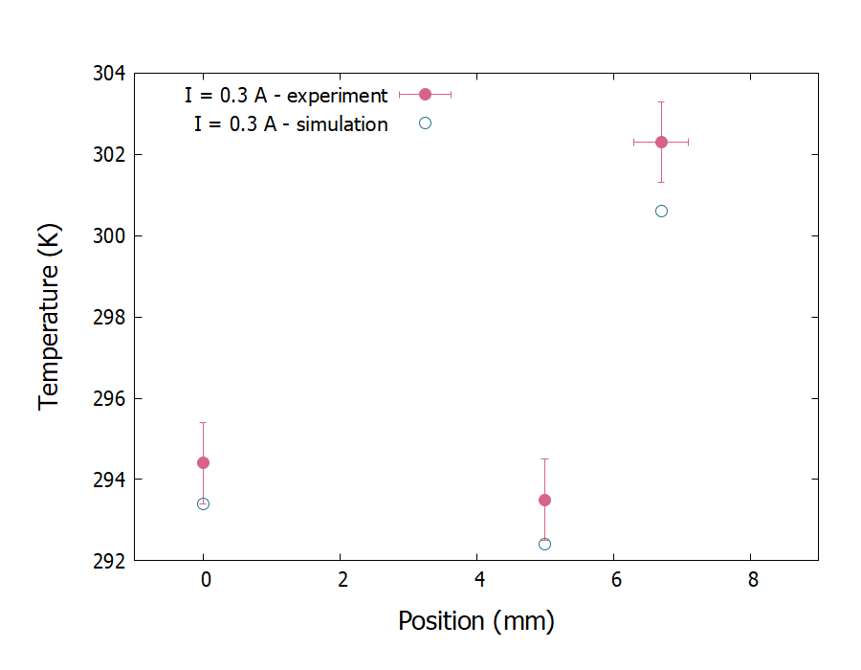

Figure Comparison of the measured and TCCbuilder calculated temperatures at I = 0.3 A.

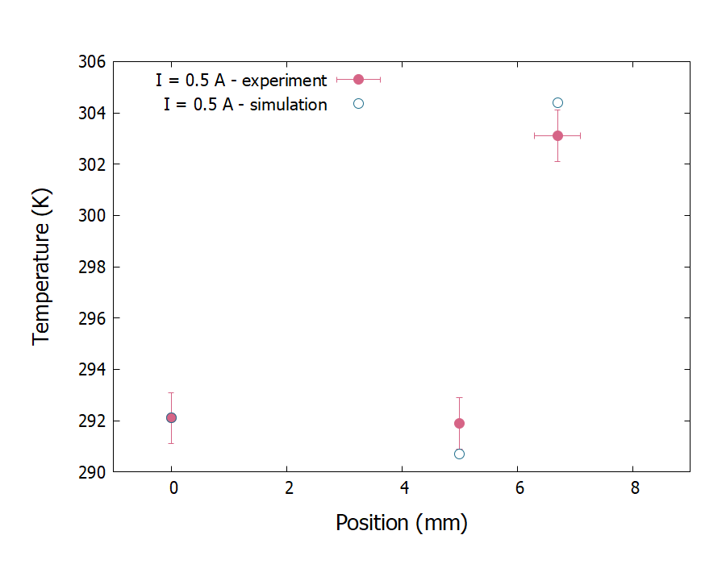

Figure Comparison of the measured and TCCbuilder calculated temperatures at I = 0.5 A.

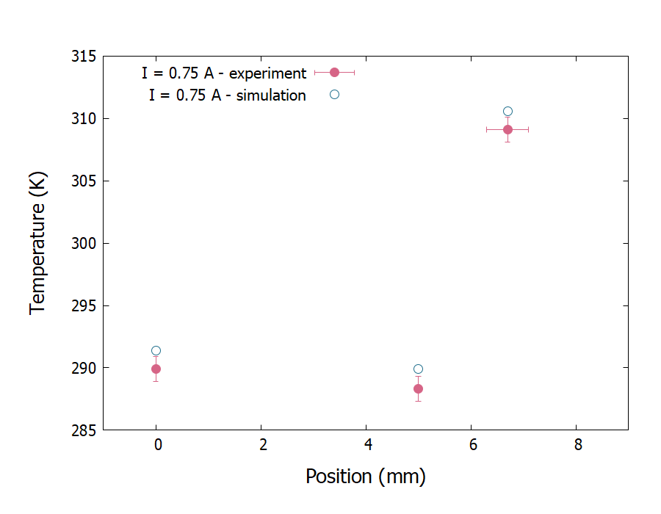

Figure Comparison of the measured and TCCbuilder calculated temperatures at I = 0.75 A.